|  |  |  |  |  |
| --- | --- | --- | --- | --- |
| **WEEK** | **VALUE PROMISE** | **MEMORY VERSE** | **CHARACTER TRAITS** | **WORK HABIT** |
| **ONE** | “ I choose to commit and work on time”. | Proverbs 22:6 | 1. Be accountable  2.Be obedient  3. Be encouraging  4. Be responsible  5. Be faithful | A goal properly set is half way reached |

Proverbs 22:6 “Train up a child in the way he should go: and when he is old he will he not depart from it”.

Work habit

Name: \_\_\_\_\_\_\_\_\_\_\_\_\_\_\_\_\_\_\_\_\_\_\_\_\_\_\_\_\_\_\_\_\_\_\_\_\_\_\_\_\_

Date: \_\_\_\_\_\_\_\_\_\_\_\_\_\_\_\_\_\_\_\_\_\_\_\_\_\_\_\_\_\_\_\_\_\_\_\_\_\_\_\_\_\_

School: \_\_\_\_\_\_\_\_\_\_\_\_\_\_\_\_\_\_\_\_\_\_\_\_\_\_\_\_\_\_\_\_\_\_\_\_\_\_\_\_\_

Spellings Corrections

1. 1.

2. 2.

3. 3.

4. 4.

5. 5.

|  |  |  |  |  |
| --- | --- | --- | --- | --- |
| **WEEK** | **VALUE PROMISE** | **MEMORY VERSE** | **CHARACTER TRAITS** | **WORK HABIT** |
| **TWO** | “ I believe in only one God as my God ”. | Matthew 25:35 | 1. Be caring  2. Be responsible  3. Be hospitable  4. Be receptive  5. Have individual responsibility | Do not settle for anything less than excellence |

Matthew 25:35 “For I was hungry and you gave me food I was thirsty and you gave me a drink, I was a stranger, and you invited me in”.

Work habit

Name: \_\_\_\_\_\_\_\_\_\_\_\_\_\_\_\_\_\_\_\_\_\_\_\_\_\_\_\_\_\_\_\_\_\_\_\_\_\_\_\_\_

Date: \_\_\_\_\_\_\_\_\_\_\_\_\_\_\_\_\_\_\_\_\_\_\_\_\_\_\_\_\_\_\_\_\_\_\_\_\_\_\_\_\_\_

School: \_\_\_\_\_\_\_\_\_\_\_\_\_\_\_\_\_\_\_\_\_\_\_\_\_\_\_\_\_\_\_\_\_\_\_\_\_\_\_\_\_

Spellings Corrections

1. 1.

2. 2.

3. 3.

4. 4.

5. 5.

**Lesson 1**

I have a little shadow it goes in and out with me. I see the shadow when it is sunny. On rainy days the shadow is not there. The shadow does what I do. When I run, It also runs. I am happy with my shadow.

1. I have a shadow.

2. My shadow goes in and with me.

3. On days the shadow is not there.

4. When I run the shadow also

5. I am with my shadow.

**Read aloud**

Sound ur says u (letter name)

Sure lure assure creature

Insure secure mixture lecture

Capture injure treasure feather

Figure picture pure

Cure manure pressure

**Construct sentences using these words.**

1

2

3

4

5

6

**In a good handwriting, write about your family**.

***Score strip***

**Corrections**

***Score strip***

Name: \_\_\_\_\_\_\_\_\_\_\_\_\_\_\_\_\_\_\_\_\_\_\_\_\_\_\_\_\_\_\_\_\_\_\_\_\_\_\_\_\_

Date: \_\_\_\_\_\_\_\_\_\_\_\_\_\_\_\_\_\_\_\_\_\_\_\_\_\_\_\_\_\_\_\_\_\_\_\_\_\_\_\_\_\_

School: \_\_\_\_\_\_\_\_\_\_\_\_\_\_\_\_\_\_\_\_\_\_\_\_\_\_\_\_\_\_\_\_\_\_\_\_\_\_\_\_\_

Work habit

Spellings Corrections

1. 1.

2. 2.

3. 3.

4. 4.

5. 5.

**Lesson 2**

**Sound ‘a ‘ as ‘ o ‘**

**Fill in the missing sound.**

1. \_\_\_lready 4. \_\_\_ard

2. a\_\_\_together 5. \_\_\_ll

3. \_\_\_\_ways

**Make sentences using the words above.**

1.

2.

3.

4.

5.

**Corrections**

***Score strip***



Checkup 1

Supervisor’s initial \_\_\_\_\_\_\_\_\_\_\_\_\_

Score \_\_\_\_\_\_\_\_\_\_\_\_\_\_\_\_\_\_\_\_\_

Supervisor’s comment \_\_\_\_\_\_\_\_\_\_\_\_\_\_\_\_\_\_\_\_\_\_\_\_

|  |  |  |  |  |
| --- | --- | --- | --- | --- |
| **WEEK** | **VALUE PROMISE** | **MEMORY VERSE** | **CHARACTER TRAITS** | **WORK HABIT** |
| **THREE** | “I will always be true and do the right things”. | Proverbs 15:3 | 1. Be true  2. Be deferent  3. Be responsible  4. Be concerned  5. Be diligent | Be gentle to all and stern to all |

Proverbs 15:3 “The eyes of the Lord are everywhere”.

Work habit

Name: \_\_\_\_\_\_\_\_\_\_\_\_\_\_\_\_\_\_\_\_\_\_\_\_\_\_\_\_\_\_\_\_\_\_\_\_\_\_\_\_\_

Date: \_\_\_\_\_\_\_\_\_\_\_\_\_\_\_\_\_\_\_\_\_\_\_\_\_\_\_\_\_\_\_\_\_\_\_\_\_\_\_\_\_\_

School: \_\_\_\_\_\_\_\_\_\_\_\_\_\_\_\_\_\_\_\_\_\_\_\_\_\_\_\_\_\_\_\_\_\_\_\_\_\_\_\_\_

Spellings Corrections

1. 1.

2. 2.

3. 3.

4. 4.

5. 5.

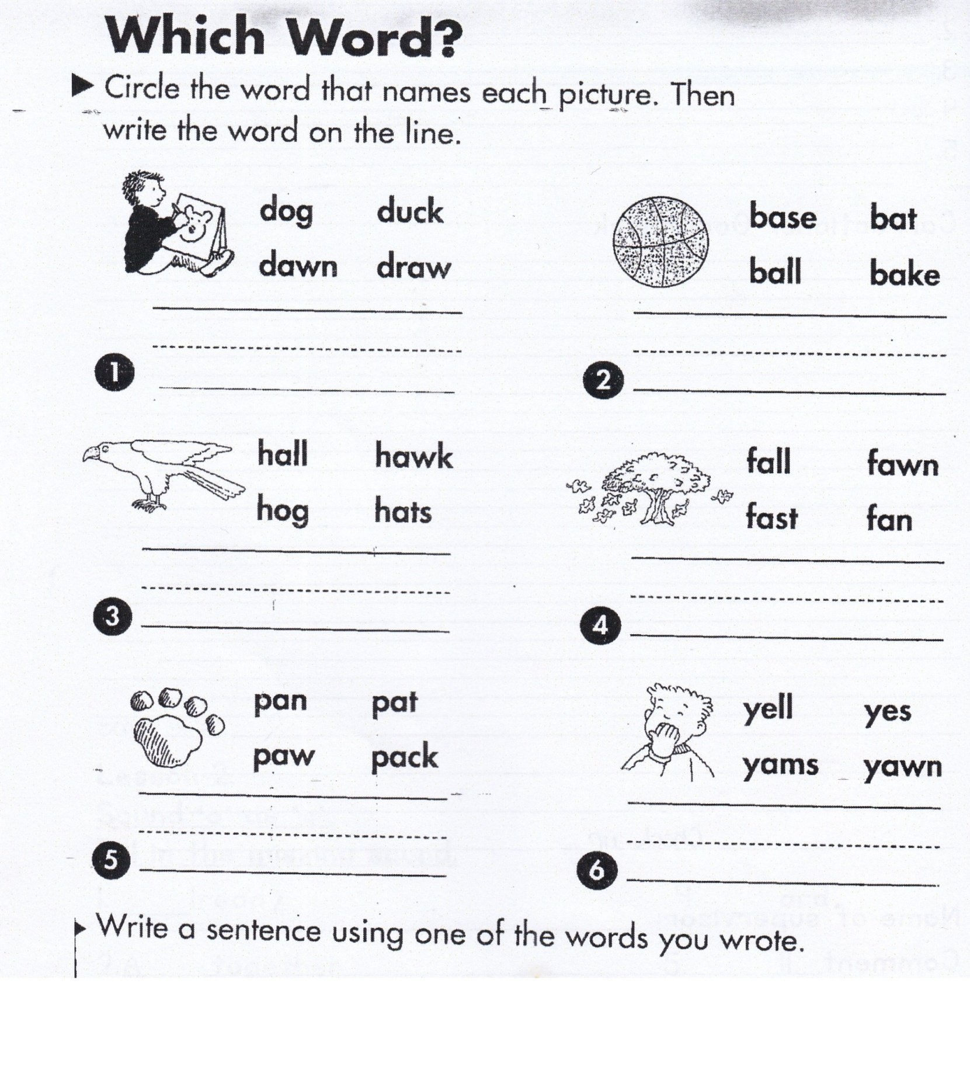

**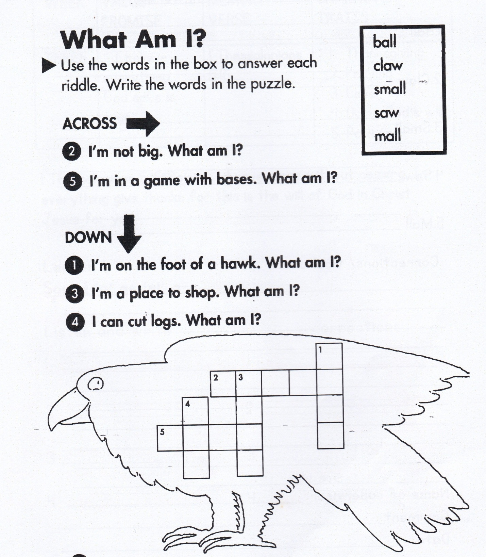**

**Make sentences from the following words.**

1. Ball

2. Claw

3. Small

4. Saw

5. Mall

**Corrections**

***Score strip***

Name: \_\_\_\_\_\_\_\_\_\_\_\_\_\_\_\_\_\_\_\_\_\_\_\_\_\_\_\_\_\_\_\_\_\_\_\_\_\_\_\_\_

Date: \_\_\_\_\_\_\_\_\_\_\_\_\_\_\_\_\_\_\_\_\_\_\_\_\_\_\_\_\_\_\_\_\_\_\_\_\_\_\_\_\_\_

School: \_\_\_\_\_\_\_\_\_\_\_\_\_\_\_\_\_\_\_\_\_\_\_\_\_\_\_\_\_\_\_\_\_\_\_\_\_\_\_\_\_

Work habit

Spellings Corrections

1. 1.

2. 2.

3. 3.

4. 4.

5. 5.

**Lesson 1**

**Sound ‘ a ‘ as ‘ei’ a-e**

**Listen and write Corrections**

1. 1.

2. 2.

3. 3.

4. 4.

5. 5.

**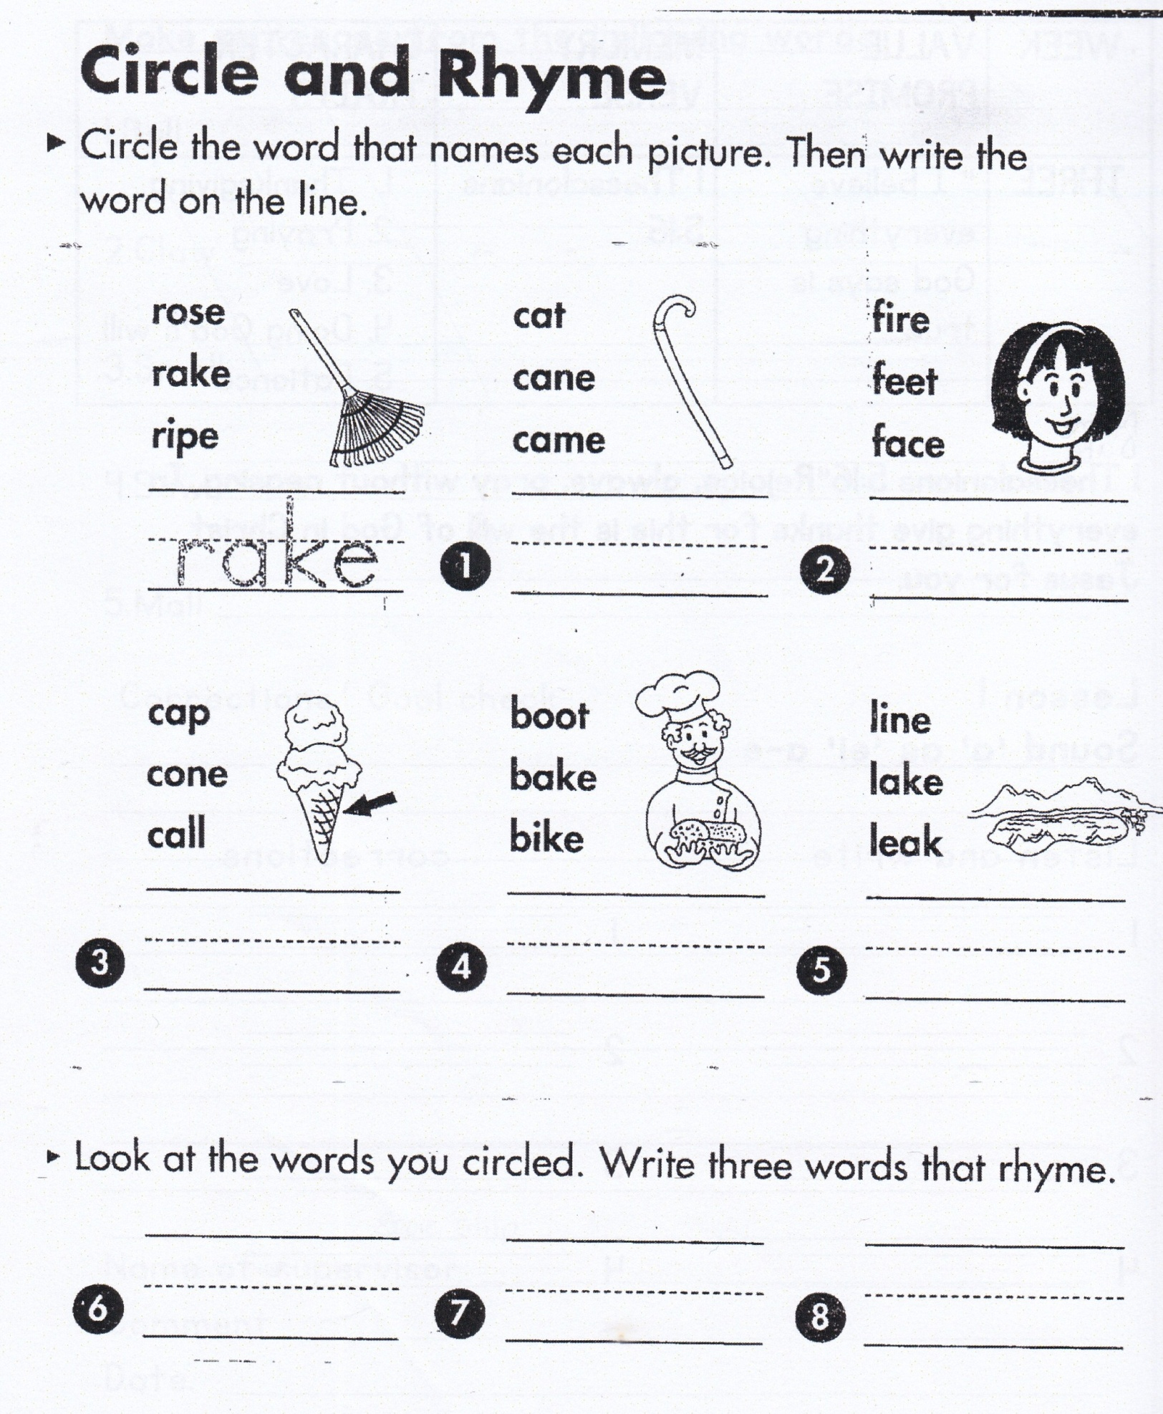**

**Make sentences using the following words.**

1. Plate

2. game

3. name

4. celebrate

5. lame

**Fill in the missing sounds**

1. sl\_\_ve 5. bec \_\_\_me

2. sh\_\_\_ve 6. g\_\_ve

3. beh\_\_ve 7. chocol\_\_te

4. 1\_\_me 8. s\_\_\_me

**Corrections**

***Score strip***



Checkup 2

Supervisor’s initial \_\_\_\_\_\_\_\_\_\_\_\_\_

Score \_\_\_\_\_\_\_\_\_\_\_\_\_\_\_\_\_\_\_\_\_

Supervisor’s comment \_\_\_\_\_\_\_\_\_\_\_\_\_\_\_\_\_\_\_\_\_\_\_\_

PROJECT WORK

In your groups, request your teachers for newspapers and look for words that rhyme. When a group gets words that rhyme, they should make two sentences for each.

|  |  |  |  |  |
| --- | --- | --- | --- | --- |
| **WEEK** | **VALUE PROMISE** | **MEMORY VERSE** | **CHARACTER TRAITS** | **WORK HABIT** |
| **FOUR** | “I choose to do what glorifies the Lord”. | 1 Peter 2:2 | 1. Be virtuous  2. Be compassionate  3. Be friendly  4. Avoid favoritism  5. Being judgmental | Be kind whenever possible. It is always possible |

1 Peter 2:2 “Like infants, take pure spiritual milk so that you may grow”.

Work habit

Name: \_\_\_\_\_\_\_\_\_\_\_\_\_\_\_\_\_\_\_\_\_\_\_\_\_\_\_\_\_\_\_\_\_\_\_\_\_\_\_\_\_

Date: \_\_\_\_\_\_\_\_\_\_\_\_\_\_\_\_\_\_\_\_\_\_\_\_\_\_\_\_\_\_\_\_\_\_\_\_\_\_\_\_\_\_

School: \_\_\_\_\_\_\_\_\_\_\_\_\_\_\_\_\_\_\_\_\_\_\_\_\_\_\_\_\_\_\_\_\_\_\_\_\_\_\_\_\_

Spellings Corrections

1. 1.

2. 2.

3. 3.

4. 4.

5. 5.

**Could it be true?**

**Read each sentence. If it is true, write yes on the**

**line .If it is not true, write no on the line.**

A snail has a shell. **yes**

A boy can sail in a gray plane.

We may get a mail today

We play inside when it rains.

We wait for a train in a cave

We ate hay and nails for lunch.

The grain paid to stay in the pail.

The mail

Mr. snail wants his mail the mail is in the box on the way to trail. He walks on the trail. It begins to rain.

His legs begins to pain , again and again. He decides to wait and get on to a train.

Answer the question and write the correct word.

1. Mr. snail wants his\_\_\_\_

2. The mail is on the ways to \_\_\_\_

3. He walks on the \_\_\_\_\_

4. He decides to \_\_\_\_\_

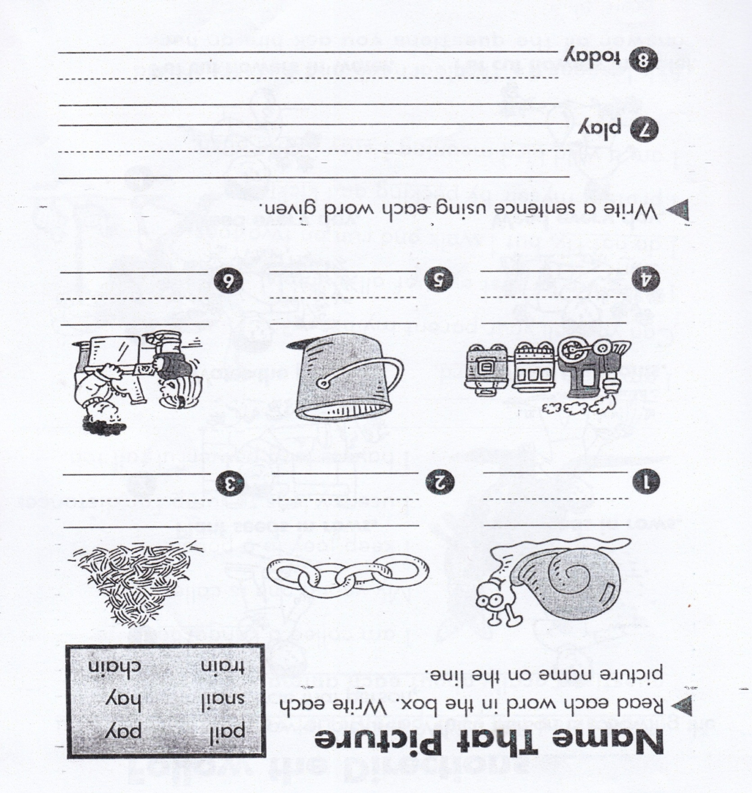

**Follow the Directions**

**Look at each row of pictures. Which person is following the directions? Circle that person.**

|  |  |
| --- | --- |
| in rows.png  Plant seeds in rows. | in rows no.png  Plant seeds in rows. |

|  |  |
| --- | --- |
| water plants nap.png  Water the plants | water plants.png  Water the plants |
| weed.png  Weed every day. | weed day.png  Weed every day. |
| cut flower.png  Put cut flowers in water | cut flower h.png  Put cut flowers in water |

**Read aloud for your parent. Let your parent ask you**

**questions orally about each animal.**

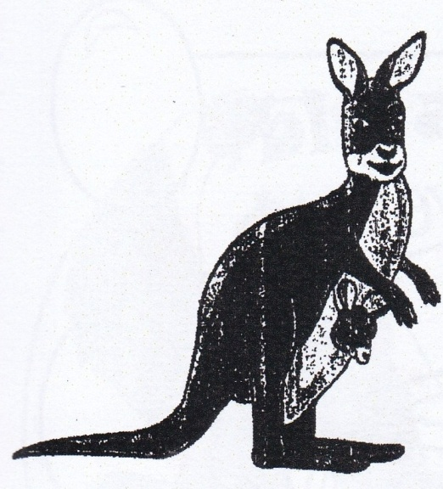 I am called a kangaroo.

My young one is called Joey.

I keep my Joey in a pouch.

I used my legs to jump far distance

I have a long powerful tail too.

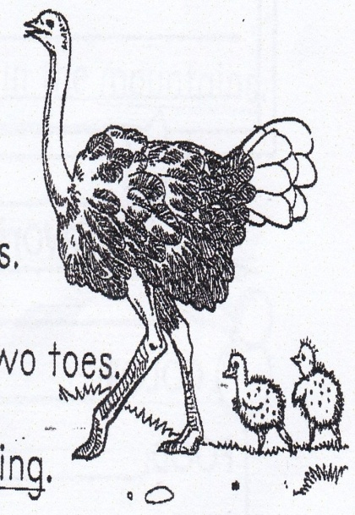I am the biggest bird

Can you tell your parent my name?

I have the largest eyes of all animals.

I do no fly. But I walk and run on two toes

I protect myself by pecking and kicking.

I am a wild bird meaning I stay in the bush.

**Ask lessons to the learners and he/ she should answer all the questions you ask him or her.**

***Score strip***

Name: \_\_\_\_\_\_\_\_\_\_\_\_\_\_\_\_\_\_\_\_\_\_\_\_\_\_\_\_\_\_\_\_\_\_\_\_\_\_\_\_\_

Date: \_\_\_\_\_\_\_\_\_\_\_\_\_\_\_\_\_\_\_\_\_\_\_\_\_\_\_\_\_\_\_\_\_\_\_\_\_\_\_\_\_\_

School: \_\_\_\_\_\_\_\_\_\_\_\_\_\_\_\_\_\_\_\_\_\_\_\_\_\_\_\_\_\_\_\_\_\_\_\_\_\_\_\_\_

Work habit

Spellings Corrections

1. 1.

2. 2.

3. 3.

4. 4.

5. 5.

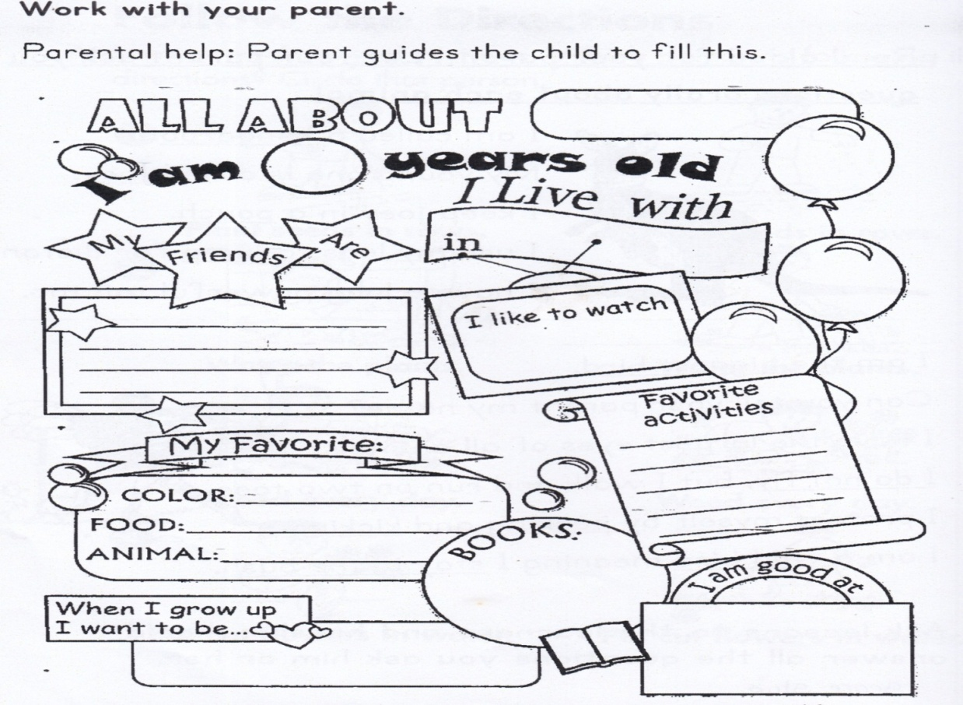

**TEAM ACADEMY**

**Read the story loud and make sentences with the underlined words.**

**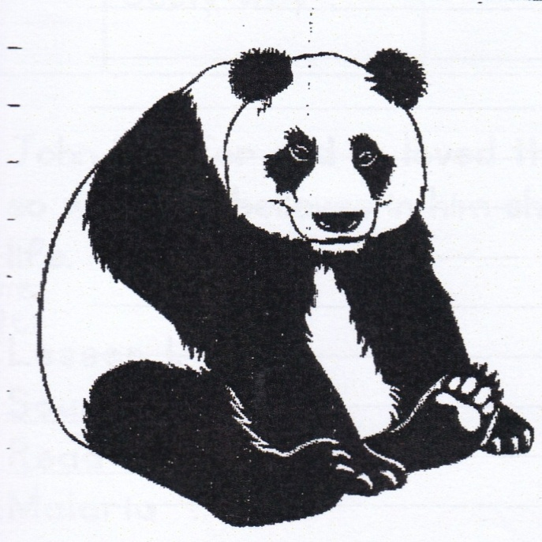 PANDA**

I am a bear called panda.

My body is covered with fur.

Black and white are my colours.

Bamboo trees are my best food.

You can visit me in China.

I stay high in the mountains

1.

2.

3.

4.

5.

**Corrections**

***Score strip***

 Checkup 3

Supervisor’s initial \_\_\_\_\_\_\_\_\_\_\_\_\_

Score \_\_\_\_\_\_\_\_\_\_\_\_\_

Supervisor’s comment \_\_\_\_\_\_\_\_\_\_\_\_\_\_\_\_\_\_\_\_\_\_\_\_

PROJECT WORK

a) In your groups, plant a sukuma wiki seed. Ensure to take care of the plant and observe the days it takes to germinate.

b) Make a report of your observations since you planted it.

|  |  |  |  |  |
| --- | --- | --- | --- | --- |
| **WEEK** | **VALUE PROMISE** | **MEMORY VERSE** | **CHARACTER TRAITS** | **WORK HABIT** |
| **FIVE** | “I will always do good to others the way I want them to do for me”. | Mathew 22:39 | 1. Be kind  2. Be considerate  3. Be equitable  4. Be empathetic  5. Be humble | Believe you can and you’re halfway there |

Mathew 22:39. “Love your neighbor as you love yourself”.

Work habit

Name: \_\_\_\_\_\_\_\_\_\_\_\_\_\_\_\_\_\_\_\_\_\_\_\_\_\_\_\_\_\_\_\_\_\_\_\_\_\_\_\_\_

Date: \_\_\_\_\_\_\_\_\_\_\_\_\_\_\_\_\_\_\_\_\_\_\_\_\_\_\_\_\_\_\_\_\_\_\_\_\_\_\_\_\_\_

School: \_\_\_\_\_\_\_\_\_\_\_\_\_\_\_\_\_\_\_\_\_\_\_\_\_\_\_\_\_\_\_\_\_\_\_\_\_\_\_\_\_

Spellings Corrections

1. 1.

2. 2.

3. 3.

4. 4.

5. 5.

**Lesson 1**

**Sound “ay”**

A FUN DAY at the Bay

I had a fun day at the ba.

I first lay in the sun The sun rays are hot then I play in the sand. The sand is soft like clay I like to stay in the bay all day

**Answer the questions and write the correct words.**

1. I had a fun day at the

2. I first in the sun.

3. The sun are.

4. The sand is soft like

**Corrections**

***Score strip***

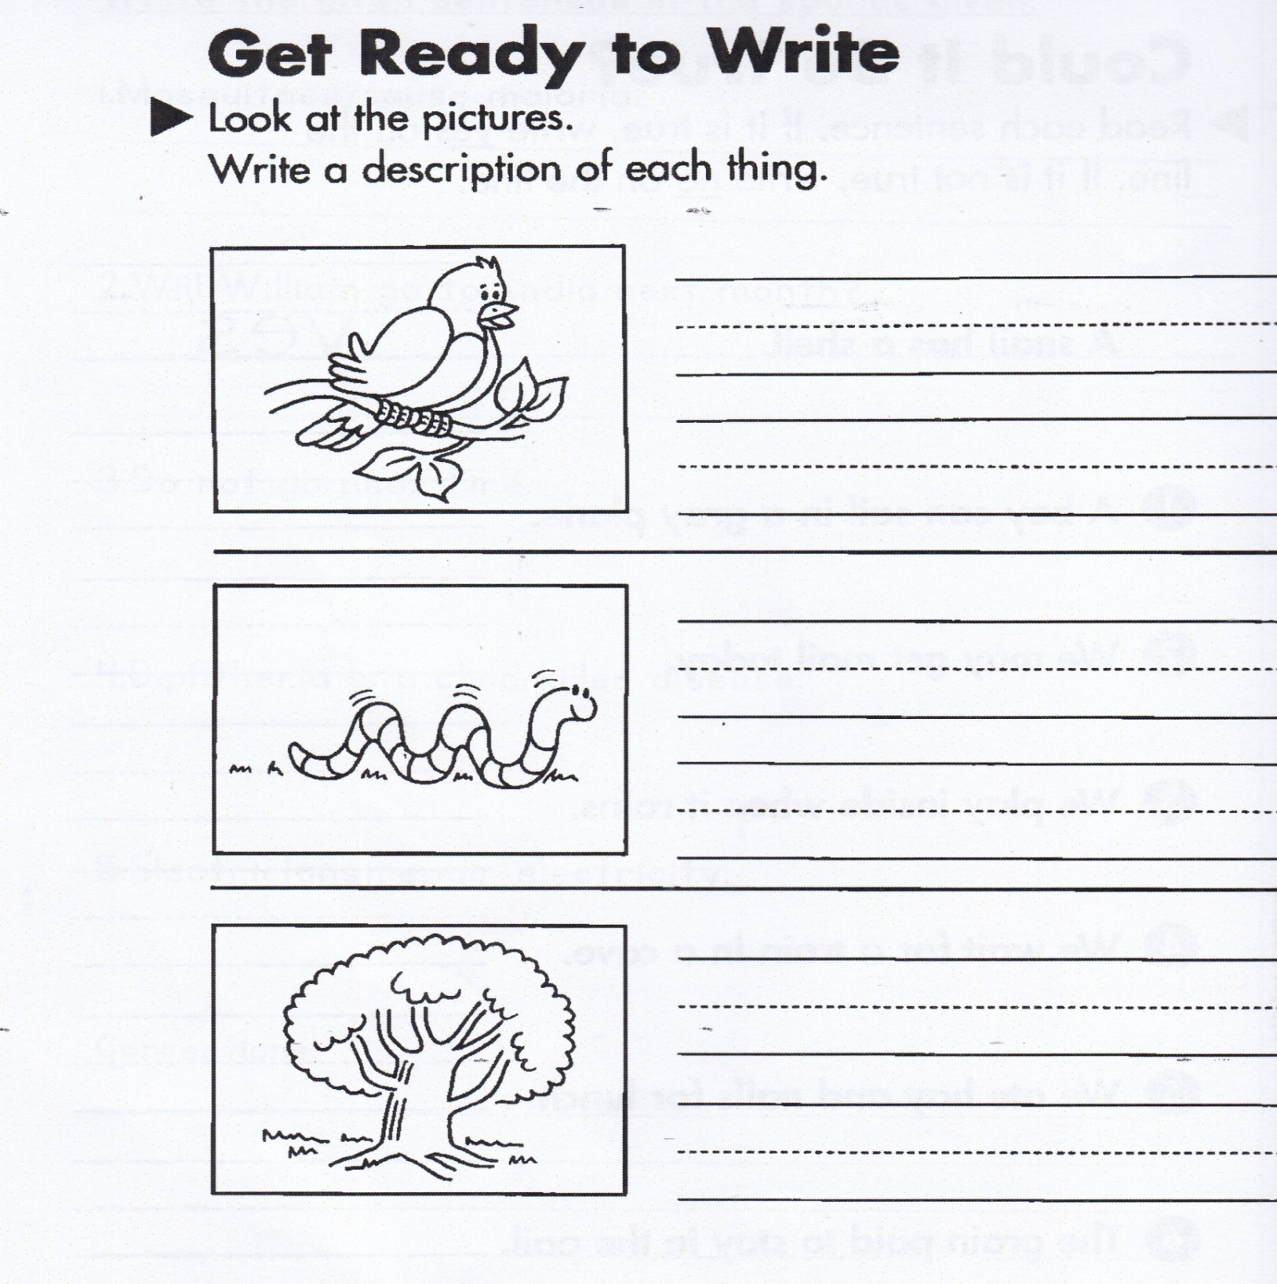

***Score strip***

Name: \_\_\_\_\_\_\_\_\_\_\_\_\_\_\_\_\_\_\_\_\_\_\_\_\_\_\_\_\_\_\_\_\_\_\_\_\_\_\_\_\_

Date: \_\_\_\_\_\_\_\_\_\_\_\_\_\_\_\_\_\_\_\_\_\_\_\_\_\_\_\_\_\_\_\_\_\_\_\_\_\_\_\_\_\_

Work habit

Spellings Corrections

1. 1.

2. 2.

3. 3.

4. 4.

5. 5.

**A story**

Once upon a time there lived a girl in Nigeria. Life in the country was so sweet because it had trained personnel like technicians, electricians, opticians, musicians but one thing I hate was they commonly suffered from diseases like malaria, and diarrhoea.

I thank God because I survived them.

**By Patricia**

Questions

1. What is the story about?

2. Name the personnel life had trained**.**

3.Name one thing that the writer hated**.**

4.Who wrote the above story?

5. Make a title for the story.

**Corrections**

***Score strip***

**Storyboard**

Story Title \_\_\_\_\_\_\_\_\_\_\_\_\_\_\_\_\_\_\_\_\_\_\_\_\_\_\_\_\_\_\_\_\_\_\_\_\_\_

Write or draw the story events in the order that they happened.

**Story of Emil Emu**

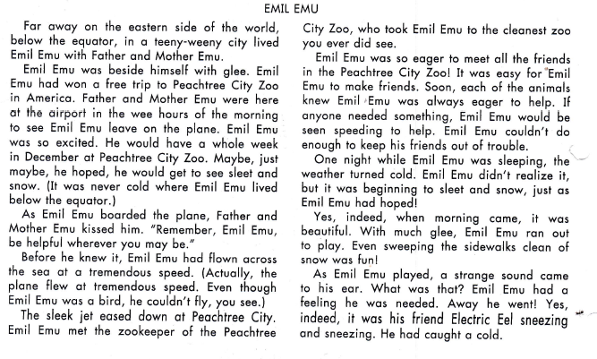

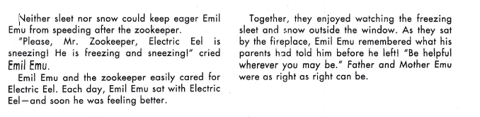

**Comprehension questions.**

1. Why was Emil Emu talking a plane trip? Could he fly?

2. What did Father and mother Emu tell he him before he left?

3. What did Emil Emu hope to see that he had never seen before?

4. Where did the plane taken him?

5. How did Emil Emu make many new friends?

6. What was Emil Emu doing when it began to snow?

**Corrections**

***Score strip***

 Checkup 4

Supervisor’s initial \_\_\_\_\_\_\_\_\_\_\_\_\_

Score \_\_\_\_\_\_\_\_\_\_\_\_\_\_\_\_\_\_\_\_\_

Supervisor’s comment \_\_\_\_\_\_\_\_\_\_\_\_\_\_\_\_\_\_\_\_\_\_\_\_

PROJECT WORK

Compose your own story about three animals. Talk about where they live, what they like to eat, and how important they are.

|  |  |  |  |  |
| --- | --- | --- | --- | --- |
| **WEEK** | **VALUE PROMISE** | **MEMORY VERSE** | **CHARACTER TRAITS** | **WORK HABIT** |
| **SIX** | “I choose to impact other people’s lives positively”. | 1st Thessalonians 5:11 | 1. Be co-operative  2. Be resourceful  3. Be fearless  4. Be dependable  5. Motivate others | Always do your best, What you plant now, you will harvest later |

1st Thessalonians 5:11 “And so encourage one another and help one another, just as you are now doing”.

Work habit

Name: \_\_\_\_\_\_\_\_\_\_\_\_\_\_\_\_\_\_\_\_\_\_\_\_\_\_\_\_\_\_\_\_\_\_\_\_\_\_\_\_\_

Date: \_\_\_\_\_\_\_\_\_\_\_\_\_\_\_\_\_\_\_\_\_\_\_\_\_\_\_\_\_\_\_\_\_\_\_\_\_\_\_\_\_\_

School: \_\_\_\_\_\_\_\_\_\_\_\_\_\_\_\_\_\_\_\_\_\_\_\_\_\_\_\_\_\_\_\_\_\_\_\_\_\_\_\_\_

Spellings Corrections

1. 1.

2. 2.

3. 3.

4. 4.

5. 5.

**TEAM ACADEMY**

**My work habit**

**First Things first**

**Read each group of sentences. Circle what happens**

**BD04915_first. Underline what happens last.**

The boy read a book in the morning.

He read another book at night.

Then he went to the library.

The girl went on a hike.

Then she went home

Then she cleaned the house.

The boy ate the fruits.

The boy went to the supermarket.

He came home with fruit

Vegetables began to grow.

They gave the seeds water.

They planted seed in the garden.

The children put the toys into a basket.

Then they put the basket a way.

The children played with the toys

**Writing moment**

**Unscrambled words ogos**

Put each set of letters in order to make **own owgr**

a word with the of sound as in low **nsow wols**

Then write the words

**Write two sentences with the words you made.**

**Corrections**

***Score strip***

Name: \_\_\_\_\_\_\_\_\_\_\_\_\_\_\_\_\_\_\_\_\_\_\_\_\_\_\_\_\_\_\_\_\_\_\_\_\_\_\_\_\_

Date: \_\_\_\_\_\_\_\_\_\_\_\_\_\_\_\_\_\_\_\_\_\_\_\_\_\_\_\_\_\_\_\_\_\_\_\_\_\_\_\_\_\_

Work habit

Spellings Corrections

1. 1.

2. 2.

3. 3.

4. 4.

5. 5.

**Lesson 2**

**Read the story and answer the questions**.

The workers are building a new house. The first thing they need is to put walls. Then they put the roof on. There are shingles on the roof to keep the rain out of the house.

Last they paint the house red. Now the house is ready to live in. Each person in the house has a different clan and totem.

Totems are part of African tradition and beliefs. They are often given basing on animals and people origin. Such animals include lion, giraffe, buffalo, and starfish among others

Come let’s complete this house together

**Main idea**

**What are the workers doing?**

**Details**

**What are the details that tell about the main idea?**

**Make sentences using the words below.**

Clan-

Totem-

**Corrections**

***Score strip***

******

Checkup 5

Supervisor’s initial \_\_\_\_\_\_\_\_\_\_\_\_\_

Score \_\_\_\_\_\_\_\_\_\_\_\_\_\_\_\_\_\_\_\_\_

Supervisor’s comment \_\_\_\_\_\_\_\_\_\_\_\_\_\_\_\_\_\_\_\_\_\_\_\_

PROJECT WORK

Write and draw the things you do the morning until evening starting from the first. Use the space below and ensure to design it.

|  |  |  |  |  |
| --- | --- | --- | --- | --- |
| **WEEK** | **VALUE PROMISE** | **MEMORY VERSE** | **CHARACTER TRAITS** | **WORK HABIT** |
| **SEVEN** | “I choose to be at peace and have good team work”. | Exodus 20:12 | 1. Be respectful  2. Be submissive  3. Be gentle  4. Be decent  5. Have self-control | Discipline is the bridge between goals and accomplishment |

Exodus 20:12 “Respect your father and mother so that you may live longer”.

Work habit

Name: \_\_\_\_\_\_\_\_\_\_\_\_\_\_\_\_\_\_\_\_\_\_\_\_\_\_\_\_\_\_\_\_\_\_\_\_\_\_\_\_\_

Date: \_\_\_\_\_\_\_\_\_\_\_\_\_\_\_\_\_\_\_\_\_\_\_\_\_\_\_\_\_\_\_\_\_\_\_\_\_\_\_\_\_\_

School: \_\_\_\_\_\_\_\_\_\_\_\_\_\_\_\_\_\_\_\_\_\_\_\_\_\_\_\_\_\_\_\_\_\_\_\_\_\_\_\_\_

Spellings Corrections

1. 1.

2. 2.

3. 3.

4. 4.

5. 5.

**Lesson 2**

**Sound ‘a’ as ‘ye’**

**Read the words out loud.**

Create theatre reaction

Creator creation reacts

Reliable recreation abbreviation

Pronunciation immediately

**Form sentence using the words given.**

1. create

2. creation

3. reaction

4. reliable

5. pronunciation

6. immediately

7. creator

8. theatre

**Corrections**

***Score strip***

Name: \_\_\_\_\_\_\_\_\_\_\_\_\_\_\_\_\_\_\_\_\_\_\_\_\_\_\_\_\_\_\_\_\_\_\_\_\_\_\_\_\_

Date: \_\_\_\_\_\_\_\_\_\_\_\_\_\_\_\_\_\_\_\_\_\_\_\_\_\_\_\_\_\_\_\_\_\_\_\_\_\_\_\_\_\_

Work habit

Spellings Corrections

1. 1.

2. 2.

3. 3.

4. 4.

5. 5.

**Choose the best word to finish each sentence.**

**Write the word on the lines.**

1. The frog into the garden pond. (jump, jumped)

2. I can the roses in the garden.(smell, smelled)

3. The sky was gray, and it (rain, rained)

4. The rain the garden (water, watered)

5. May we some flowers today? (pick, picked)

**Corrections**

***Score strip***

 Checkup 6

Supervisor’s initial \_\_\_\_\_\_\_\_\_\_\_\_\_

Score \_\_\_\_\_\_\_\_\_\_\_\_\_\_\_\_\_\_\_\_\_

Supervisor’s comment \_\_\_\_\_\_\_\_\_\_\_\_\_\_\_\_\_\_\_\_\_\_\_\_

PROJECT WORK

Join in different teams and come up with words and their past tenses. The team with the most words in 8 minutes will win the challenge.

|  |  |  |  |  |
| --- | --- | --- | --- | --- |
| **WEEK** | **VALUE PROMISE** | **MEMORY VERSE** | **CHARACTER TRAITS** | **WORK HABIT** |
| **EIGHT** | “I choose to be responsible in everything I do”. | Mathew 14:20-21 | 1. Be deferent  2. Be compassionate  3. Be friendly  4. Be purposeful  5. Be responsible | Discipline is what you must have to resist the lies of excuses |

Mathew: 14:20-21 “And they collected twelve baskets of leftover food”.

Work habit

Name: \_\_\_\_\_\_\_\_\_\_\_\_\_\_\_\_\_\_\_\_\_\_\_\_\_\_\_\_\_\_\_\_\_\_\_\_\_\_\_\_\_

Date: \_\_\_\_\_\_\_\_\_\_\_\_\_\_\_\_\_\_\_\_\_\_\_\_\_\_\_\_\_\_\_\_\_\_\_\_\_\_\_\_\_\_

School: \_\_\_\_\_\_\_\_\_\_\_\_\_\_\_\_\_\_\_\_\_\_\_\_\_\_\_\_\_\_\_\_\_\_\_\_\_\_\_\_\_

Spellings Corrections

1. 1.

2. 2.

3. 3.

4. 4.

5. 5.

**Sound i – e.**

Read loud

alive site bike strick

line vine crime pine

slide tide dice spice

bite tile dive time

five wise fine wife

life side shine reptile

kite size spite slice

wipe whine white strick

Construct sentences using the above words.

1.

2.

3.

4.

5.

6.

7.

**Sound igh(i)**

fight night, height

light, flight, weight,

bright right, sigh,

slight, delight, high,

highlight, tight, plight, might

Construct sentences using the above words.

1.

2.

3.

4.

5.

6.

**Writing**

**Form more sentences using the words given.**

1.Created In the beginning God created heaven and earth.

1. earth

2.

3.

2. Theater people who want to watch plays go to theaters

2.

3.

3.Recreation Recreation is when people have free time

after work

2.

3.

Story of George Gerbil

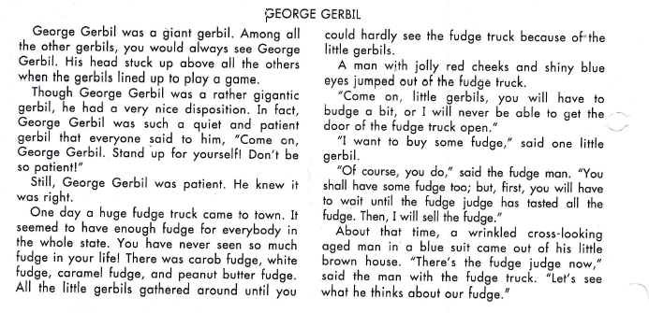

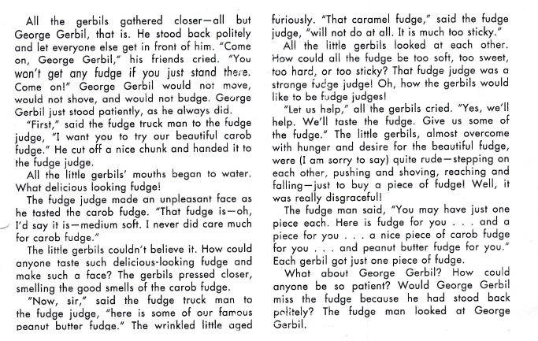

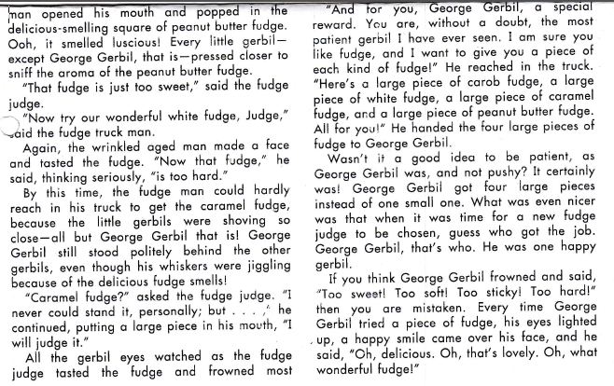

Comprehension Questions.

1. What size was George Gerbil?

2. What were the character traits that George Gerbils showed?

3. What came to town that excited the gerbils?

4. What did all the gerbils – excited George Gerbil – do?

5. Did the fudge like the fudge he tasted?

6. What did the fudge says was wrong with the fudge?

7. Which gerbil was patient and would not shove

8. Who noticed how well behaved George Gerbils was?

9. What did the fudge truck man do to reward George Gerbil?

10. Who became the new fudge judge?

11. Is it better to push or to be patient?

Use the letters st, sn, or sp to finish each word on the

steps. Write sentences for two of the words you made.

in ap

ill ack

and eed

eak ore

10

10 10

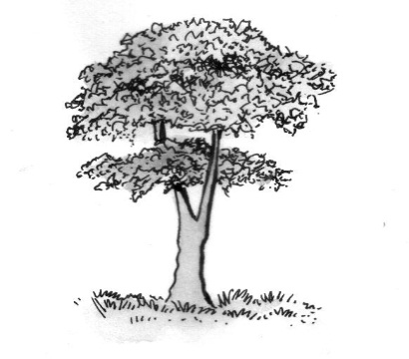One day a little girl lost her cat. The cat went up

a tree and could not get down. So the little girl

asked her big sister of help. Her sister used

a ladder to get the cat down. The little girl

was very happy to have her cat back.

|  |  |
| --- | --- |
| **Who is the story about?** | **What happens in the story?** |
| **Where does it take place?** | **How does the story end?** |

Give the story a title.

***Score strip***

**Lesson 2**

Name: \_\_\_\_\_\_\_\_\_\_\_\_\_\_\_\_\_\_\_\_\_\_\_\_\_\_\_\_\_\_\_\_\_\_\_\_\_\_\_\_\_

Date: \_\_\_\_\_\_\_\_\_\_\_\_\_\_\_\_\_\_\_\_\_\_\_\_\_\_\_\_\_\_\_\_\_\_\_\_\_\_\_\_\_\_

Work habit

Spellings Corrections

1. 1.

2. 2.

3. 3.

4. 4.

5. 5.

**Unscrambled words** rea ate

Put each set of letters in order rhea tmea

to make A word with the **ea** eatch che

sound as in **ear.**

Then write the words.

Write two sentences with the words you made.

1.

2.

**Story of Ilex ibex**

**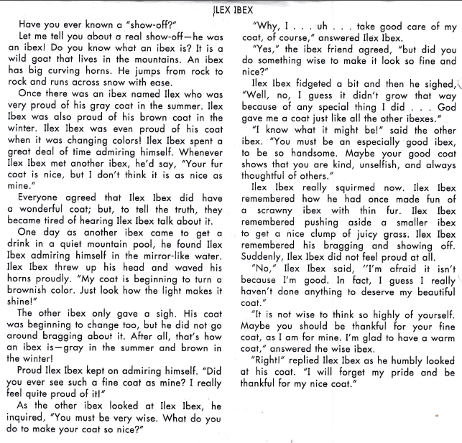**

**BOOK REPORT**

**Comprehension questions.**

**1.** What is an ibex?

2. For what did Ilex ibex feel so much pride?

3. Why did the other ibexes get tired of ilex ibex?

4. What color was ilex ibex’s coat in the summer?

5. What color was his coat in the summer?

6. Did ilex ibex’s coat pretty because he was so very good?

7. Was ilex ibex’s coat pretty because he was so very good?

8. Who really made ilex ibex’s coat beautiful?

9. Did Ilex ibex learn to be thankful for his lovely worm coat?

**Corrections**

***Score strip***

 Checkup 7

Supervisor’s initial \_\_\_\_\_\_\_\_\_\_\_\_\_

Score \_\_\_\_\_\_\_\_\_\_\_\_\_\_\_\_\_\_\_\_\_

Supervisor’s comment \_\_\_\_\_\_\_\_\_\_\_\_\_\_\_\_\_\_\_\_\_\_\_\_

PROJECT WORK

Make one word for each of the sounds ea, st, and sn. Request your teachers for a hard box and in your different teams, draw and cut out pictures for the words. For each of the words, form two sentences.

|  |  |  |  |  |
| --- | --- | --- | --- | --- |
| **WEEK** | **VALUE PROMISE** | **MEMORY VERSE** | **CHARACTER TRAITS** | **WORK HABIT** |
| **NINE** | “I will always do my honest part”. | Ephesians 4:29 | 1. Be honest  2. Be truthful  3. Be reliable  4. Be realistic  5. Be faithful. | Excellence is not a skill. It’s an attitude |

Ephesians 4:29. “Let no corrupting word come out of your mouth but only very good for building up others”.

Work habit

Name: \_\_\_\_\_\_\_\_\_\_\_\_\_\_\_\_\_\_\_\_\_\_\_\_\_\_\_\_\_\_\_\_\_\_\_\_\_\_\_\_\_

Date: \_\_\_\_\_\_\_\_\_\_\_\_\_\_\_\_\_\_\_\_\_\_\_\_\_\_\_\_\_\_\_\_\_\_\_\_\_\_\_\_\_\_

School: \_\_\_\_\_\_\_\_\_\_\_\_\_\_\_\_\_\_\_\_\_\_\_\_\_\_\_\_\_\_\_\_\_\_\_\_\_\_\_\_\_

Spellings Corrections

1. 1.

2. 2.

3. 3.

4. 4.

5. 5.

**BOOK REPORT**

**Reading time**

Choose a book from the library and read it. Answer all the questions that follow and make sure you evaluate it below

**Book Report**

**Book Tile**

**I like this book because**

**This picture shows what I like best about the book.**

Name: \_\_\_\_\_\_\_\_\_\_\_\_\_\_\_\_\_\_\_\_\_\_\_\_\_\_\_\_\_\_\_\_\_\_\_\_\_\_\_\_\_

Date: \_\_\_\_\_\_\_\_\_\_\_\_\_\_\_\_\_\_\_\_\_\_\_\_\_\_\_\_\_\_\_\_\_\_\_\_\_\_\_\_\_\_

Work habit

Spellings Corrections

1. 1.

2. 2.

3. 3.

4. 4.

5. 5.

**Lesson 3**

**Letter writing**

**(Friendly letter)**

CARSON SCHOOLS,

P.O. Box 28951,

KAMPALA.

15th January 2024

Dear Cathy,

How are you and how are your parents? Let me hope you are fine. I have written this letter to invite you to my birthday party.

Your loving friend,

Silver

**Evaluation**

Tom writes to Cathy greeting her. He also asks about

how the parents are. He later invites Cathy to his birthday

party which he does not give the date. He signs the letter as he finishes.

**Description: C:\Documents and Settings\esther\Local Settings\Temporary Internet Files\Content.IE5\N666YB5R\MP910220658[1].jpgDescription: C:\Documents and Settings\esther\Local Settings\Temporary Internet Files\Content.IE5\N666YB5R\MP910220658[1].jpgDescription: C:\Documents and Settings\esther\Local Settings\Temporary Internet Files\Content.IE5\N666YB5R\MP910220658[1].jpgDescription: C:\Documents and Settings\esther\Local Settings\Temporary Internet Files\Content.IE5\N666YB5R\MP910220658[1].jpgDescription: C:\Documents and Settings\esther\Local Settings\Temporary Internet Files\Content.IE5\N666YB5R\MP910220658[1].jpgDescription: C:\Documents and Settings\esther\Local Settings\Temporary Internet Files\Content.IE5\N666YB5R\MP910220658[1].jpgDescription: C:\Documents and Settings\esther\Local Settings\Temporary Internet Files\Content.IE5\N666YB5R\MP910220658[1].jpgDescription: C:\Documents and Settings\esther\Local Settings\Temporary Internet Files\Content.IE5\N666YB5R\MP910220658[1].jpgDescription: C:\Documents and Settings\esther\Local Settings\Temporary Internet Files\Content.IE5\N666YB5R\MP910220658[1].jpgDescription: C:\Documents and Settings\esther\Local Settings\Temporary Internet Files\Content.IE5\N666YB5R\MP910220658[1].jpgDescription: C:\Documents and Settings\esther\Local Settings\Temporary Internet Files\Content.IE5\N666YB5R\MP910220658[1].jpgDescription: C:\Documents and Settings\esther\Local Settings\Temporary Internet Files\Content.IE5\N666YB5R\MP910220658[1].jpgDescription: C:\Documents and Settings\esther\Local Settings\Temporary Internet Files\Content.IE5\N666YB5R\MP910220658[1].jpgDescription: C:\Documents and Settings\esther\Local Settings\Temporary Internet Files\Content.IE5\N666YB5R\MP910220658[1].jpgDescription: C:\Documents and Settings\esther\Local Settings\Temporary Internet Files\Content.IE5\N666YB5R\MP910220658[1].jpgDescription: C:\Documents and Settings\esther\Local Settings\Temporary Internet Files\Content.IE5\N666YB5R\MP910220658[1].jpgDescription: C:\Documents and Settings\esther\Local Settings\Temporary Internet Files\Content.IE5\N666YB5R\MP910220658[1].jpgDescription: C:\Documents and Settings\esther\Local Settings\Temporary Internet Files\Content.IE5\N666YB5R\MP910220658[1].jpgWrite a letter of invitation.**

**Description: C:\Documents and Settings\esther\Local Settings\Temporary Internet Files\Content.IE5\N666YB5R\MP910220658[1].jpgDescription: C:\Documents and Settings\esther\Local Settings\Temporary Internet Files\Content.IE5\N666YB5R\MP910220658[1].jpgDescription: C:\Documents and Settings\esther\Local Settings\Temporary Internet Files\Content.IE5\N666YB5R\MP910220658[1].jpgDescription: C:\Documents and Settings\esther\Local Settings\Temporary Internet Files\Content.IE5\N666YB5R\MP910220658[1].jpgDescription: C:\Documents and Settings\esther\Local Settings\Temporary Internet Files\Content.IE5\N666YB5R\MP910220658[1].jpgDescription: C:\Documents and Settings\esther\Local Settings\Temporary Internet Files\Content.IE5\N666YB5R\MP910220658[1].jpgDescription: C:\Documents and Settings\esther\Local Settings\Temporary Internet Files\Content.IE5\N666YB5R\MP910220658[1].jpgDescription: C:\Documents and Settings\esther\Local Settings\Temporary Internet Files\Content.IE5\N666YB5R\MP910220658[1].jpgDescription: C:\Documents and Settings\esther\Local Settings\Temporary Internet Files\Content.IE5\N666YB5R\MP910220658[1].jpgDescription: C:\Documents and Settings\esther\Local Settings\Temporary Internet Files\Content.IE5\N666YB5R\MP910220658[1].jpgDescription: C:\Documents and Settings\esther\Local Settings\Temporary Internet Files\Content.IE5\N666YB5R\MP910220658[1].jpgDescription: C:\Documents and Settings\esther\Local Settings\Temporary Internet Files\Content.IE5\N666YB5R\MP910220658[1].jpg**

Description: C:\Documents and Settings\esther\Local Settings\Temporary Internet Files\Content.IE5\N666YB5R\MP910220658[1].jpgDescription: C:\Documents and Settings\esther\Local Settings\Temporary Internet Files\Content.IE5\N666YB5R\MP910220658[1].jpgDescription: C:\Documents and Settings\esther\Local Settings\Temporary Internet Files\Content.IE5\N666YB5R\MP910220658[1].jpgDescription: C:\Documents and Settings\esther\Local Settings\Temporary Internet Files\Content.IE5\N666YB5R\MP910220658[1].jpgDescription: C:\Documents and Settings\esther\Local Settings\Temporary Internet Files\Content.IE5\N666YB5R\MP910220658[1].jpgDescription: C:\Documents and Settings\esther\Local Settings\Temporary Internet Files\Content.IE5\N666YB5R\MP910220658[1].jpgDescription: C:\Documents and Settings\esther\Local Settings\Temporary Internet Files\Content.IE5\N666YB5R\MP910220658[1].jpgDescription: C:\Documents and Settings\esther\Local Settings\Temporary Internet Files\Content.IE5\N666YB5R\MP910220658[1].jpgDescription: C:\Documents and Settings\esther\Local Settings\Temporary Internet Files\Content.IE5\N666YB5R\MP910220658[1].jpgDescription: C:\Documents and Settings\esther\Local Settings\Temporary Internet Files\Content.IE5\N666YB5R\MP910220658[1].jpgDescription: C:\Documents and Settings\esther\Local Settings\Temporary Internet Files\Content.IE5\N666YB5R\MP910220658[1].jpgDescription: C:\Documents and Settings\esther\Local Settings\Temporary Internet Files\Content.IE5\N666YB5R\MP910220658[1].jpgDescription: C:\Documents and Settings\esther\Local Settings\Temporary Internet Files\Content.IE5\N666YB5R\MP910220658[1].jpgDescription: C:\Documents and Settings\esther\Local Settings\Temporary Internet Files\Content.IE5\N666YB5R\MP910220658[1].jpgDescription: C:\Documents and Settings\esther\Local Settings\Temporary Internet Files\Content.IE5\N666YB5R\MP910220658[1].jpgDescription: C:\Documents and Settings\esther\Local Settings\Temporary Internet Files\Content.IE5\N666YB5R\MP910220658[1].jpgDescription: C:\Documents and Settings\esther\Local Settings\Temporary Internet Files\Content.IE5\N666YB5R\MP910220658[1].jpg

Description: C:\Documents and Settings\esther\Local Settings\Temporary Internet Files\Content.IE5\N666YB5R\MP910220658[1].jpgDescription: C:\Documents and Settings\esther\Local Settings\Temporary Internet Files\Content.IE5\N666YB5R\MP910220658[1].jpgDescription: C:\Documents and Settings\esther\Local Settings\Temporary Internet Files\Content.IE5\N666YB5R\MP910220658[1].jpgDescription: C:\Documents and Settings\esther\Local Settings\Temporary Internet Files\Content.IE5\N666YB5R\MP910220658[1].jpgDescription: C:\Documents and Settings\esther\Local Settings\Temporary Internet Files\Content.IE5\N666YB5R\MP910220658[1].jpgDescription: C:\Documents and Settings\esther\Local Settings\Temporary Internet Files\Content.IE5\N666YB5R\MP910220658[1].jpgDescription: C:\Documents and Settings\esther\Local Settings\Temporary Internet Files\Content.IE5\N666YB5R\MP910220658[1].jpg

Description: C:\Documents and Settings\esther\Local Settings\Temporary Internet Files\Content.IE5\N666YB5R\MP910220658[1].jpgDescription: C:\Documents and Settings\esther\Local Settings\Temporary Internet Files\Content.IE5\N666YB5R\MP910220658[1].jpgDescription: C:\Documents and Settings\esther\Local Settings\Temporary Internet Files\Content.IE5\N666YB5R\MP910220658[1].jpgDescription: C:\Documents and Settings\esther\Local Settings\Temporary Internet Files\Content.IE5\N666YB5R\MP910220658[1].jpgDescription: C:\Documents and Settings\esther\Local Settings\Temporary Internet Files\Content.IE5\N666YB5R\MP910220658[1].jpgDescription: C:\Documents and Settings\esther\Local Settings\Temporary Internet Files\Content.IE5\N666YB5R\MP910220658[1].jpgDescription: C:\Documents and Settings\esther\Local Settings\Temporary Internet Files\Content.IE5\N666YB5R\MP910220658[1].jpgDescription: C:\Documents and Settings\esther\Local Settings\Temporary Internet Files\Content.IE5\N666YB5R\MP910220658[1].jpgDescription: C:\Documents and Settings\esther\Local Settings\Temporary Internet Files\Content.IE5\N666YB5R\MP910220658[1].jpgDescription: C:\Documents and Settings\esther\Local Settings\Temporary Internet Files\Content.IE5\N666YB5R\MP910220658[1].jpg

Description: C:\Documents and Settings\esther\Local Settings\Temporary Internet Files\Content.IE5\N666YB5R\MP910220658[1].jpgDescription: C:\Documents and Settings\esther\Local Settings\Temporary Internet Files\Content.IE5\N666YB5R\MP910220658[1].jpg

Description: C:\Documents and Settings\esther\Local Settings\Temporary Internet Files\Content.IE5\N666YB5R\MP910220658[1].jpg

Description: C:\Documents and Settings\esther\Local Settings\Temporary Internet Files\Content.IE5\N666YB5R\MP910220658[1].jpg

Description: C:\Documents and Settings\esther\Local Settings\Temporary Internet Files\Content.IE5\N666YB5R\MP910220658[1].jpgDescription: C:\Documents and Settings\esther\Local Settings\Temporary Internet Files\Content.IE5\N666YB5R\MP910220658[1].jpgDescription: C:\Documents and Settings\esther\Local Settings\Temporary Internet Files\Content.IE5\N666YB5R\MP910220658[1].jpg

Evaluation

1. Who will I invite?

2. Where will I invite this person?

3. When will this happen?

4. Why would this person want to come?

***Score strip***

 Checkup 8

Supervisor’s initial \_\_\_\_\_\_\_\_\_\_\_\_\_

Score \_\_\_\_\_\_\_\_\_\_\_\_\_\_\_\_\_\_\_\_\_

Supervisor’s comment \_\_\_\_\_\_\_\_\_\_\_\_\_\_\_\_\_\_\_\_\_\_\_\_

|  |  |  |  |  |
| --- | --- | --- | --- | --- |
| **WEEK** | **VALUE PROMISE** | **MEMORY VERSE** | **CHARACTER TRAITS** | **WORK HABIT** |
| **TEN** | “I choose to always do the right”. | James: 4:6 | 1. Be appreciative  2. Be patient  3. Be self-controlled  4. Be peaceful  5. Listen to others | Never, Never, Never give up |

James: 4:6. “God opposes the proud and give grace to the humble”.

Work habit

Name: \_\_\_\_\_\_\_\_\_\_\_\_\_\_\_\_\_\_\_\_\_\_\_\_\_\_\_\_\_\_\_\_\_\_\_\_\_\_\_\_\_

Date: \_\_\_\_\_\_\_\_\_\_\_\_\_\_\_\_\_\_\_\_\_\_\_\_\_\_\_\_\_\_\_\_\_\_\_\_\_\_\_\_\_\_

School: \_\_\_\_\_\_\_\_\_\_\_\_\_\_\_\_\_\_\_\_\_\_\_\_\_\_\_\_\_\_\_\_\_\_\_\_\_\_\_\_\_

Spellings Corrections

1. 1.

2. 2.

3. 3.

4. 4.

5. 5.

**Lesson 1**

**BD04915_Finish the box from toad to frog. Use words from the box and write these words on the lines.**

Dear frog,

Thank you for the seeds! I them today.

I to see if they would grow. I even

at them. The seeds did not grow. They being

afraid when I read to them.

planted

waited

yelled

stopped

Your friend,

Toad

The word I is always capitalized

Read both letters. Write the word I where it belongs.

Dear Mom,

am having fun. Grandpa and went fishing. Guess who caught a fish? did !

Love,

Tasha

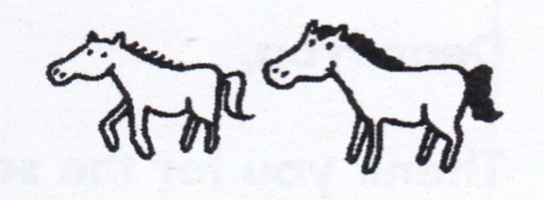

Dear Leon,

can’t wait to tell you about my trip. But am too busy now. will write to you later.

Your friend,

Joel

***Score strip***



Checkup 9

Supervisor’s initial \_\_\_\_\_\_\_\_\_\_\_\_\_\_

Score \_\_\_\_\_\_\_\_\_\_\_\_\_\_

Supervisor’s comment \_\_\_\_\_\_\_\_\_\_\_\_\_\_\_\_\_\_\_\_\_\_\_\_\_\_

**LETTER PROJECT WORK**

1. Cut out an envelope and design it. Write a letter to your mum and dad. Thank them for paying your school fees and loving you. Also thank them for bringing you to Carson Schools. After that, put your letter in an envelope and take it to them.

2. Imagine that you have been asked to write a letter to your friend. (Use your school address). Write the letter telling her/him anything of your choice.